### Windows Server 2016 Technical Preview 5 - Overview

This guide includes:

* How Windows Server 2016 TP5 looks?
* What changes are done?
* What Roles and Features are Added, Removed or Updated in Windows Server 2016 TP5?

To know about Windows Server 2016 TP5 Features, [**Click Here!**](https://technet.microsoft.com/en-us/windows-server-docs/get-started/what-s-new-in-windows-server-2016-technical-preview-5)  
  
I will share what differences I have observed as compared to Windows Server 2012 R2...   
  
So, Let's start with screenshots...

## Installation Guide:

Installation for Windows Server 2016 TP5 is same as earlier version except 1 thing that You have to provide Product Key for Evaluation version as well before choose edition. So, Microsoft has provided evaluation product key for STD & DC Editions. Below are the Product Key for the same:

* Standard Key: MFY9F-XBN2F-TYFMP-CCV49-RMYVH
* Datacenter Key: 6XBNX-4JQGW-QX6QG-74P76-72V67

For More Information, [**Click Here!**](https://blogs.technet.microsoft.com/ausoemteam/2016/04/28/windows-server-2016-technical-preview-5-available-for-download/)

## WINDOWS SERVER 2016 TECHNICAL PREVIEW 5 - OVERVIEW:

Default Screen:

By default, first login to server will give You looks almost similar to Windows 10... Yes it looks like that:

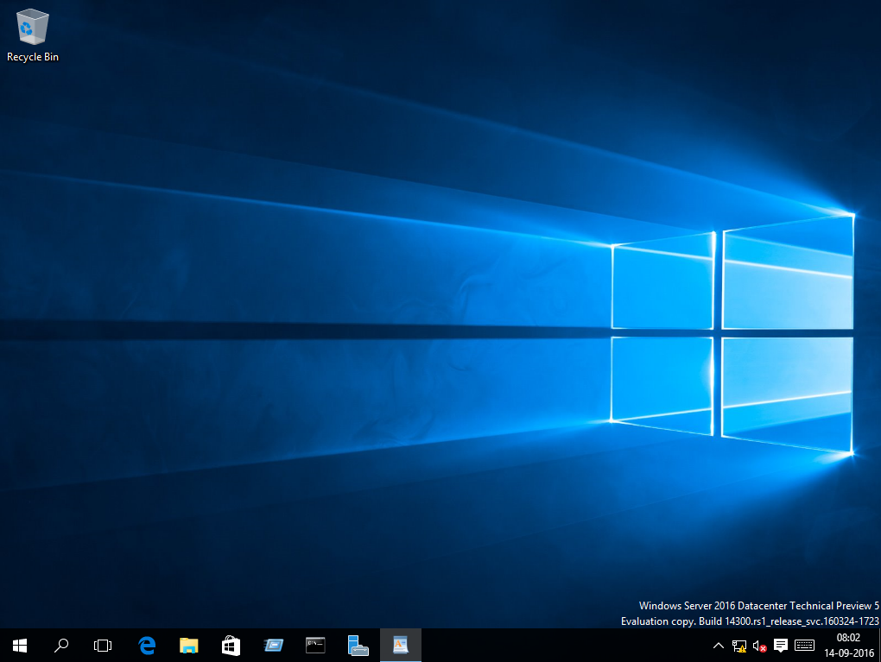

Multiple Desktop:

You can create session based multiple desktop for remote users using this feature... One of the great features which will help to provide session based remote access to multiple users with individual’s rights:

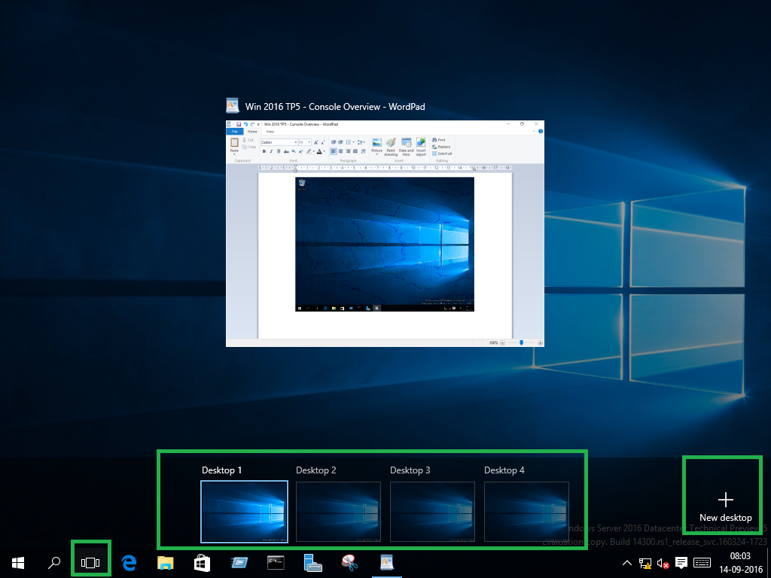

Windows Defender (Enabled by Default):

This feature is added which is enabled by default:

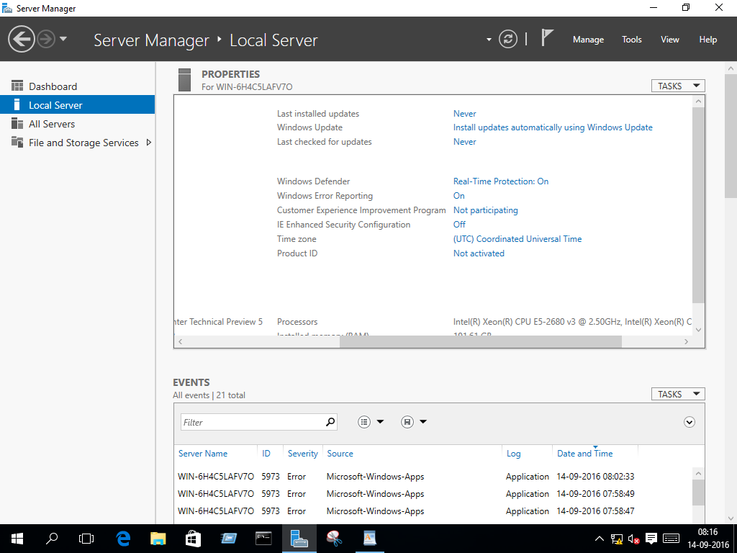

**Shut Down option** is same like in Windows 10 now. 

## COMPARISON OF ROLES & FEATURES BETWEEN WINDOWS SERVER 2016 TP5 & WINDOWS SERVER 2012 R2:

### New Roles Added/Upgraded in Windows Server 2016 TP5:

#### *Device Health Attestation:*

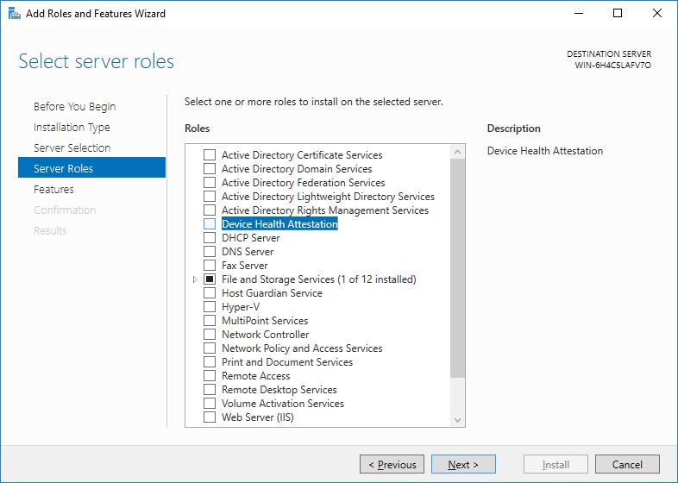

#### *Host Guardian Service:*

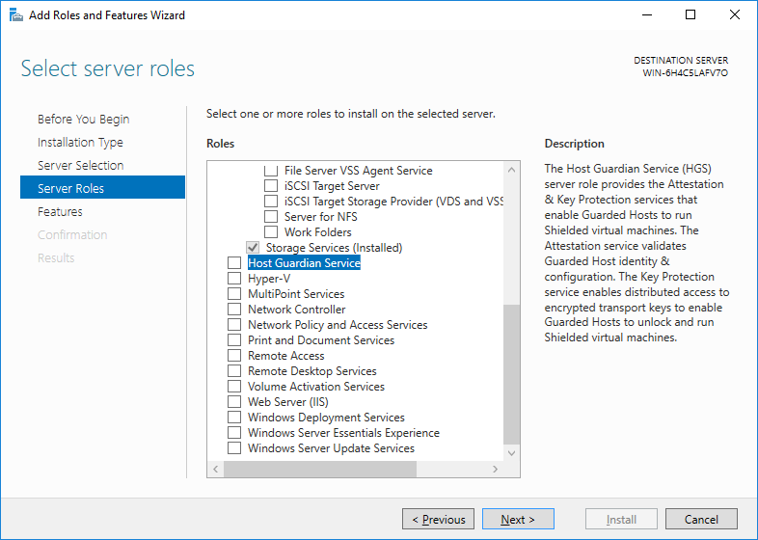

#### *Multi-point Service:*

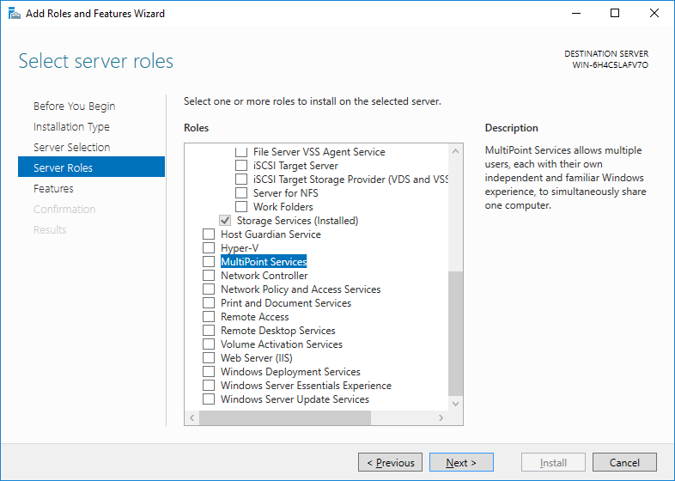

#### *Network Controller:*

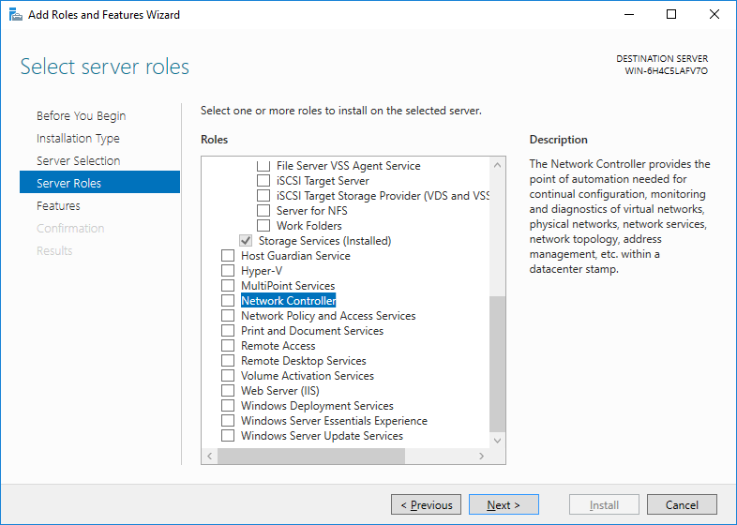

### Roles Removed from Windows Server 2016 TP5:

**NOTE:** Below are the roles which are available in Windows Server 2012 R2 but removed from Windows Server 2016. I have shared screenshots from Windows Server 2012 R2 after comparison between both OS version.

#### *Application Server:*

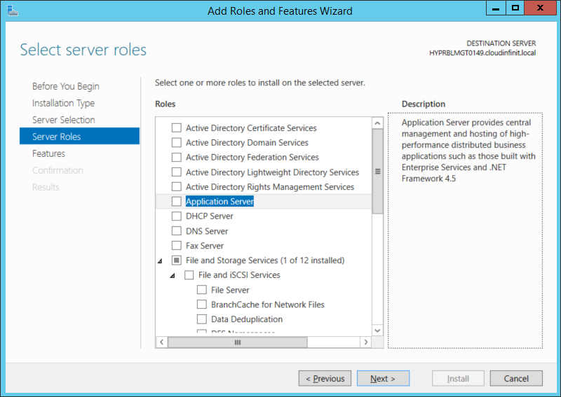

Only 1 Role is removed.

### New Features Added/Upgraded in Windows Server 2016 TP5:

#### *.Net Framework is upgraded to 4.6 from 4.5 version:*

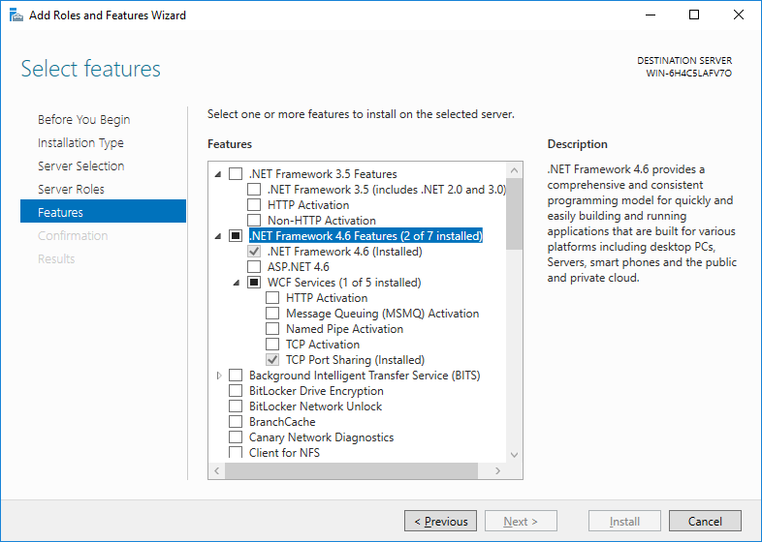

#### *Canary Network Diagnostic:*

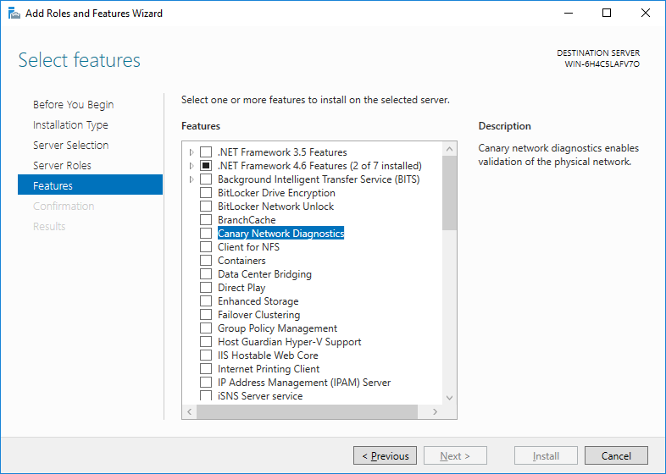

#### *Containers:*

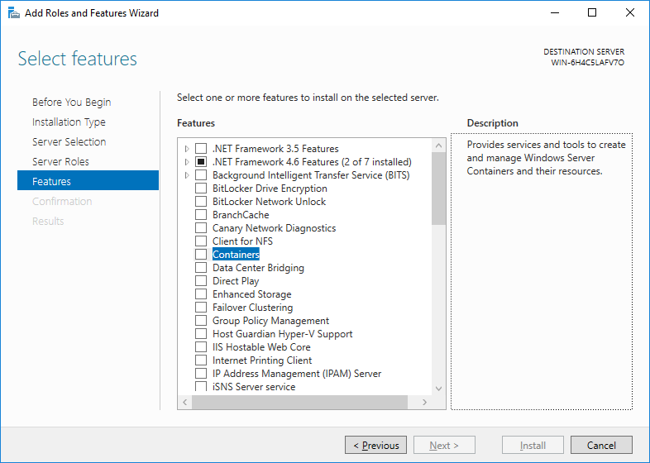

#### *Host Guardian Hyper-V Support:*

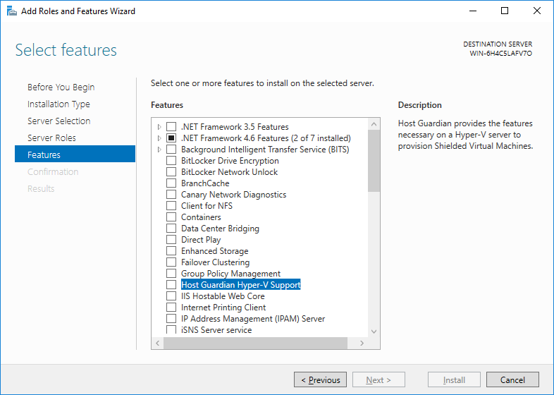

#### *Multi-point Connectors:*

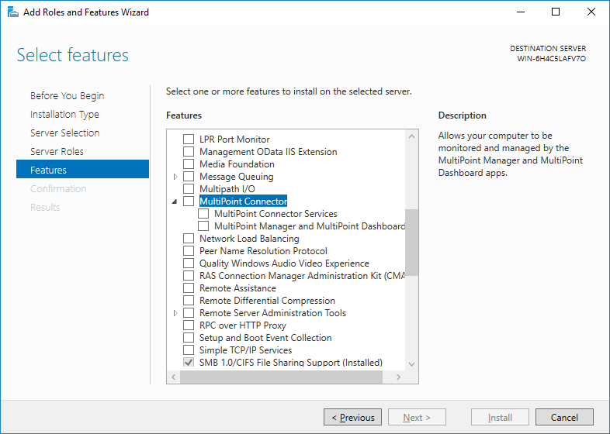

#### *Shielded VM Tools & Storage Replica Modules for Windows PowerShell:*

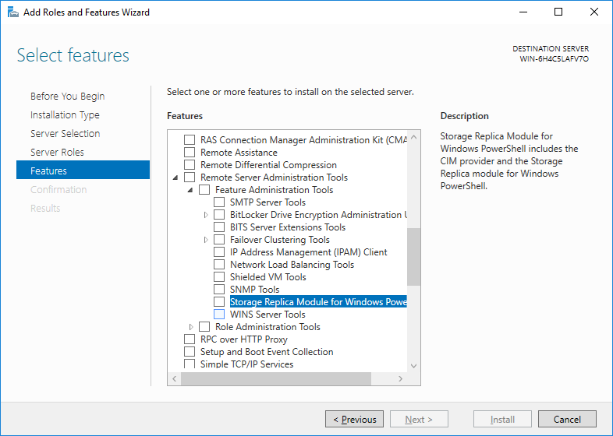

#### *Network Controller Management Tool:*

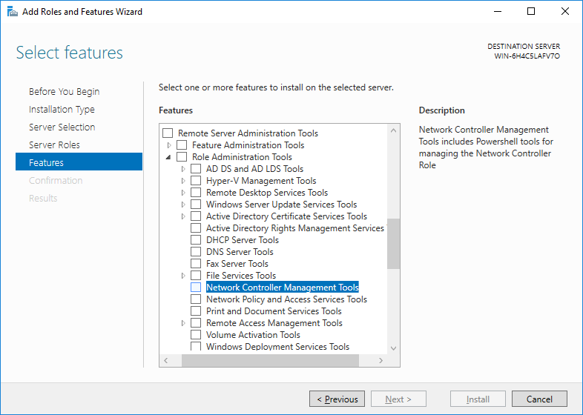

#### *Setup & Boot event collection:*

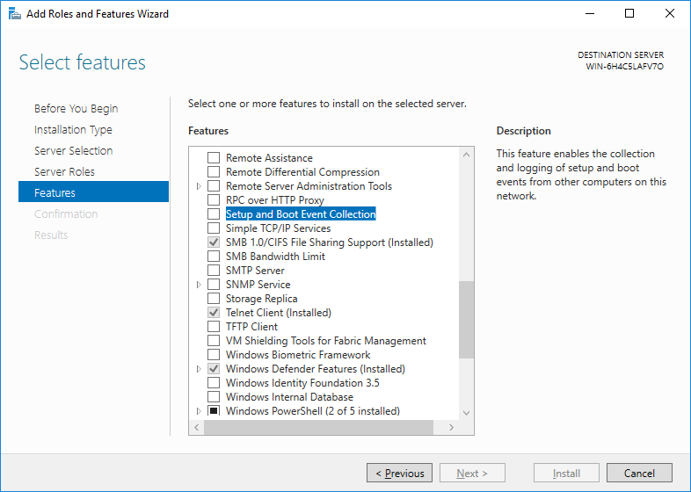

#### *Storage Replica:*

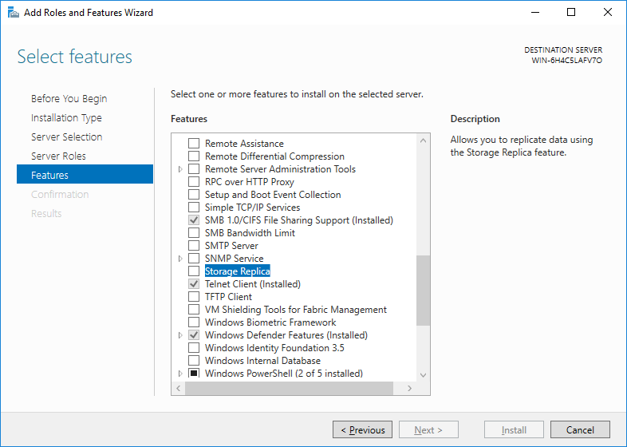

#### *VM Shielding Tool for Fabric Management:*

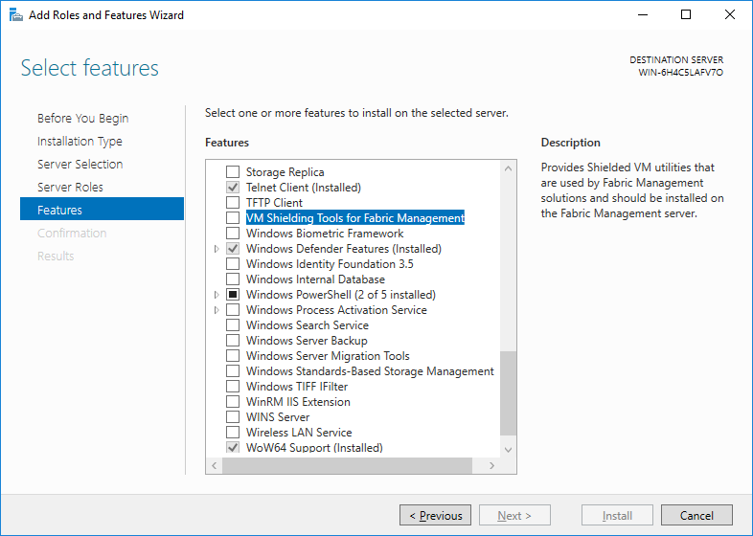

#### *Windows Defender:*

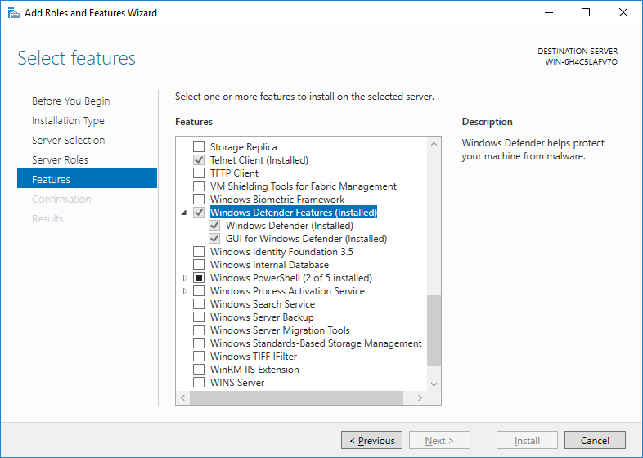

#### *Windows Firewall is upgraded to 5.1 from 4.0:*

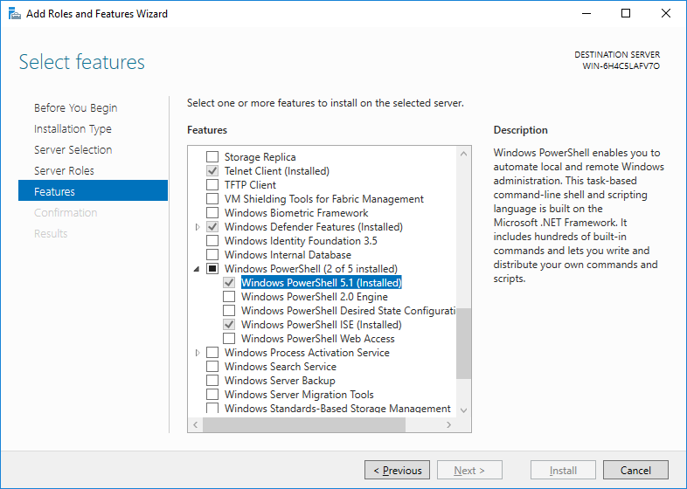

#### *Removed Features from Windows Server 2016 TP5:*

**NOTE:** Below are the features which are available in Windows Server 2012 R2 but removed from Windows Server 2016. I have shared screenshots from Windows Server 2012 R2 after comparison between both OS version.

#### *Server for NIS Tool (Deprecated):*

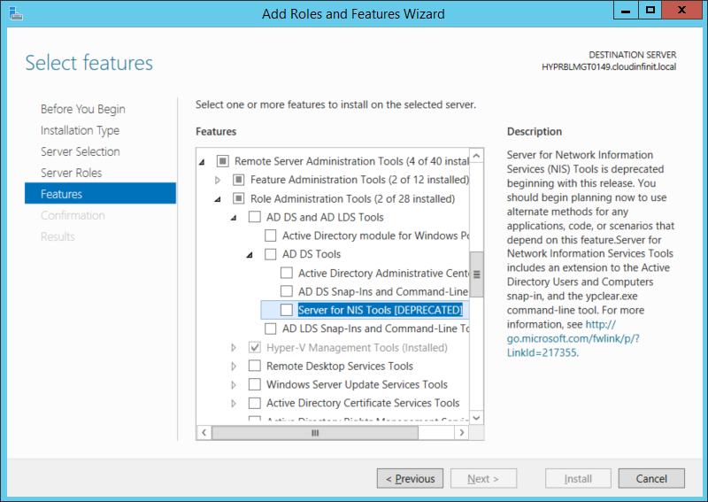

#### *Share & Storage Management Tool:*

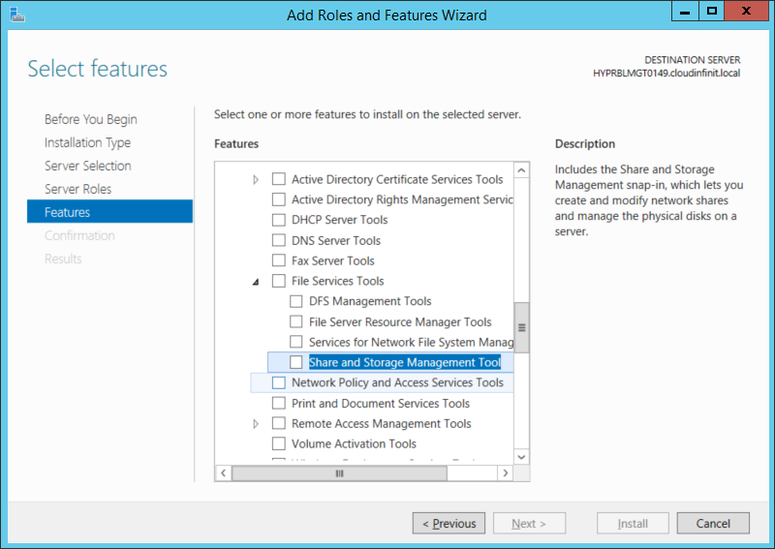

#### *Telnet Server:*



#### *User Interface & Infrastructure:*

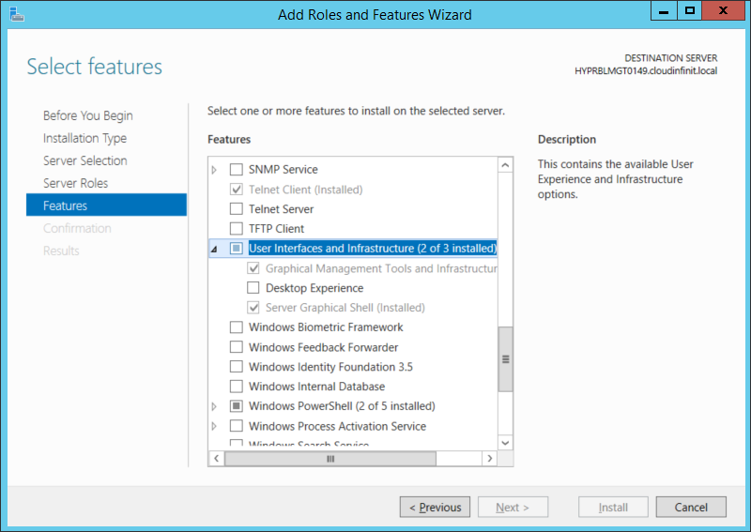

#### *Windows Feedback Forwarder:*

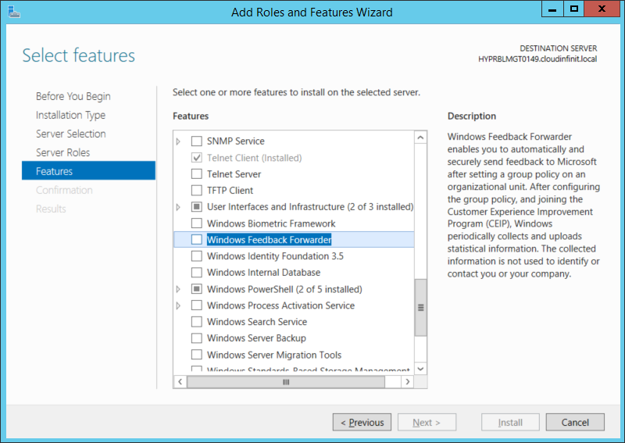

This is overall overview what I observed after comparison with Win Server 2012 R2.

**Thanks,**

**Mayank Dhama**

**Happy to Help ☺**

You can join my Facebook group for updates on trending technologies/technical references/issues etc:

<https://www.facebook.com/groups/technicalskillsenhancementworld/>

Visit My Blog Site:

<http://www.mdtechskillssolutions.com/>

Technet Profile:

<https://social.technet.microsoft.com/profile/mayank%20dhama/>